

travel agency



 

By

ANIRUDDHA PONNURI

CLASS: XII_S1

CERTIFICATE

This is to certify that the project entitled “TRAVEL AGENCY”, which deals with creating a system for making cancel bookings in different hotels in different cities is submitted by ANIRUDDHA PONNURI. This project is bonafide piece of work carried out with the consultation of supervisor

ACKNOWLEDGEMENT

The satisfaction and euphoria that accompany the successful completion of any task would be incomplete without mentioning the name of the people whose constant guidance and encouragement has crowed all our effort with success.

“**THANK YOU**”. These two words are very less to be measured when it comes to extend my gratitude towards all those who have made my project learning and a memorable experience.

I own my sincere and whole hearted thanks to **MVN SCHOOL** who allowed me to make project report on **DATABASE CONNECTIVITY**. Also, I am grateful to **MS** **PRAGYA** my teacher for constantly guiding me and tackling a variety of hurdle with implicit patience throughout my research project infused in me a great inspiration and confidence in taking up this study in right direction.

Words cannot express my sincere thanks to **CBSE BOARD** who had been a constant source of guidance and give us a chance to make a project.

Also, I am sincerely thankful to all the respondents of the questionnaire who spared their valuable time. And last but not the least I would like to convey my heartiest thanks to my parents and my friends with whose support and guidance this assignment of mine is successfully accomplished.

ANIRUDDHA PONNURI

XII_S1

**CONTENTS**

* System Description at a Glance.....(1)
* Database design ...........................(2)
* Project code snipet.......................(3)
* Program output............................(4)

**System description at a glance**

**TRAVEL AGENCY** provides a system that processes request to booking cancelations , updating the charges in/of a hotel in different locations

Following are the activities of Travel agency system:

1. Log in with the system

2. Change charges of current booking

3. view current booking

4. Make booking

5. Cancel booking

First the user needs to log in with the system to make the necessary changes. The login form enables the user to do so.

Then user can select between option i.e. to add , view , delete booking, view payment

Under view payment option admin can change tax and discount in percentage

All these facilities provide various benefits and this system would make travel agency system much efficient.

DATABASE DESIGN

THE DATABASE “PROJECT” USED IN THIS CODE CONTAINS FOLLOWING TABLES

* TABLE:-- USER

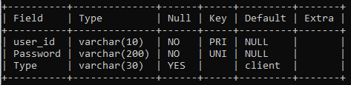

CREATE TABLE `user` (

`user_id` varchar(10) NOT NULL,

`Password` varchar(200) NOT NULL,

`Type` varchar(30) DEFAULT 'client',

PRIMARY KEY (`user_id`),

UNIQUE KEY `Password_UNIQUE` (`Password`))

* TABLE:- CLIENT

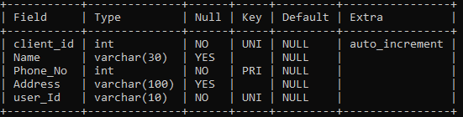

CREATE TABLE `client` (

`client_id` int NOT NULL AUTO_INCREMENT,

`Name` varchar(30) DEFAULT NULL,

`Phone_No` int NOT NULL,

`Address` varchar(100) DEFAULT NULL,

`user_Id` varchar(10) NOT NULL,

PRIMARY KEY (`Phone_No`),

UNIQUE KEY `user_Id_UNIQUE` (`user_Id`),

UNIQUE KEY `client_id_UNIQUE` (`client_id`))

* TABLE: -- BOOKING

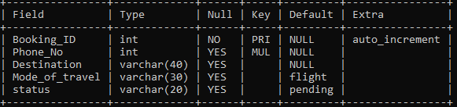

CREATE TABLE `booking` (

`Booking_ID` int NOT NULL AUTO_INCREMENT,

`Phone_No` int DEFAULT NULL,

`Destination` varchar(40) DEFAULT NULL,

`Mode_of_travel` varchar(30) DEFAULT 'flight',

`status` varchar(20) DEFAULT 'pending',

PRIMARY KEY (`Booking_ID`),

KEY `Phone_No` (`Phone_No`),

CONSTRAINT `booking_ibfk_1` FOREIGN KEY (`Phone_No`) REFERENCES `client` (`Phone_No`))

* TABLE: --DESTINATION

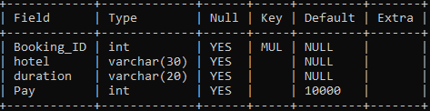

CREATE TABLE `destination` (

`Booking_ID` int DEFAULT NULL,

`hotel` varchar(30) DEFAULT NULL,

`duration` varchar(20) DEFAULT NULL,

`Pay` int DEFAULT '10000',

KEY `Booking_ID` (`Booking_ID`),CONSTRAINT `destination_ibfk_1` FOREIGN KEY (`Booking_ID`) REFERENCES `booking` (`Booking_ID`))

* TABLE: -- PAYMENT

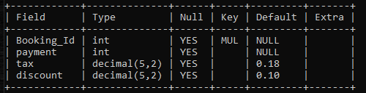

CREATE TABLE `payment` (

`Booking_Id` int DEFAULT NULL,

`payment` int DEFAULT NULL,

`tax` decimal(5,2) DEFAULT '0.18',

`discount` decimal(5,2) DEFAULT '0.10',

KEY `Booking_Id` (`Booking_Id`),

CONSTRAINT `payment_ibfk_1` FOREIGN KEY (`Booking_Id`) REFERENCES `booking` (`Booking_ID`))

Project code:

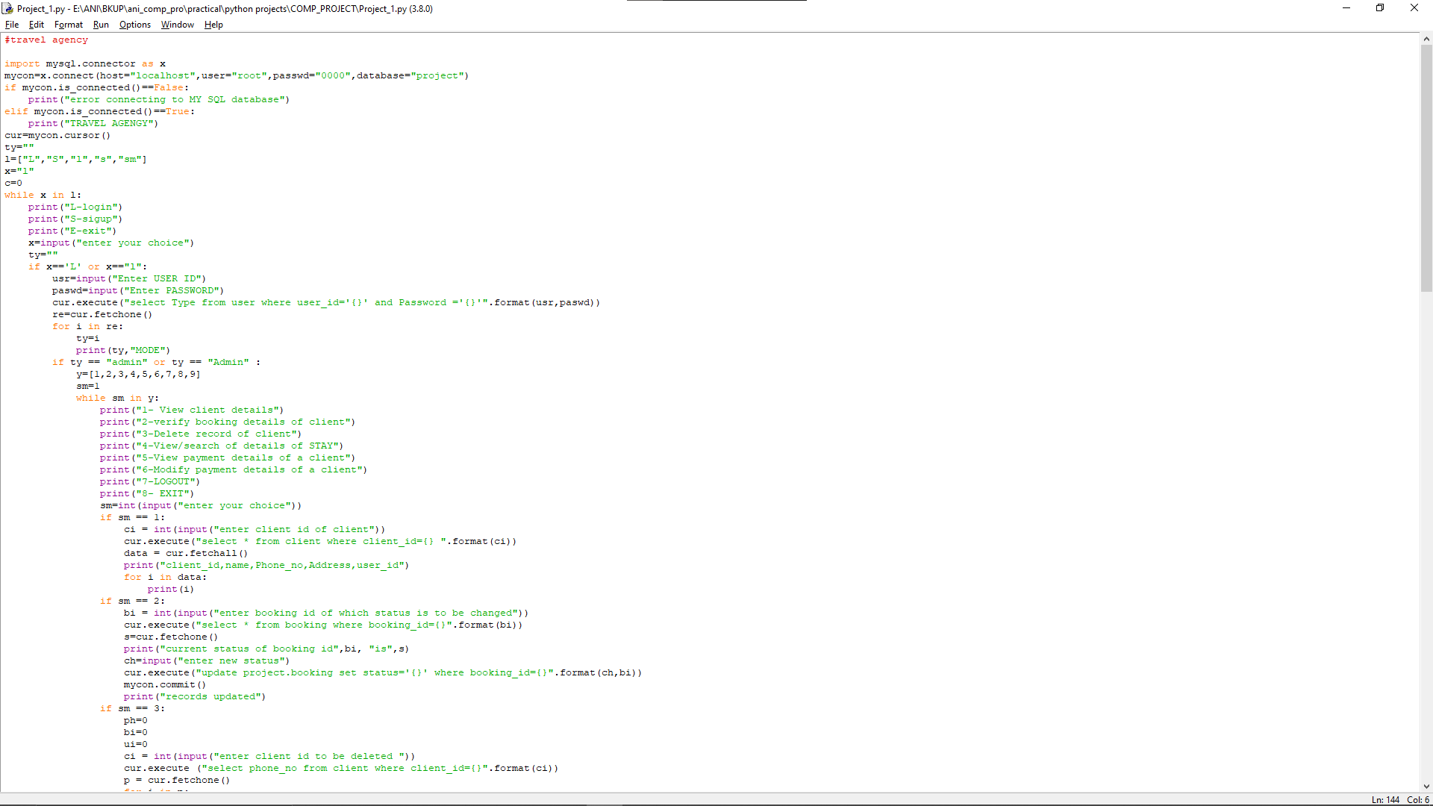

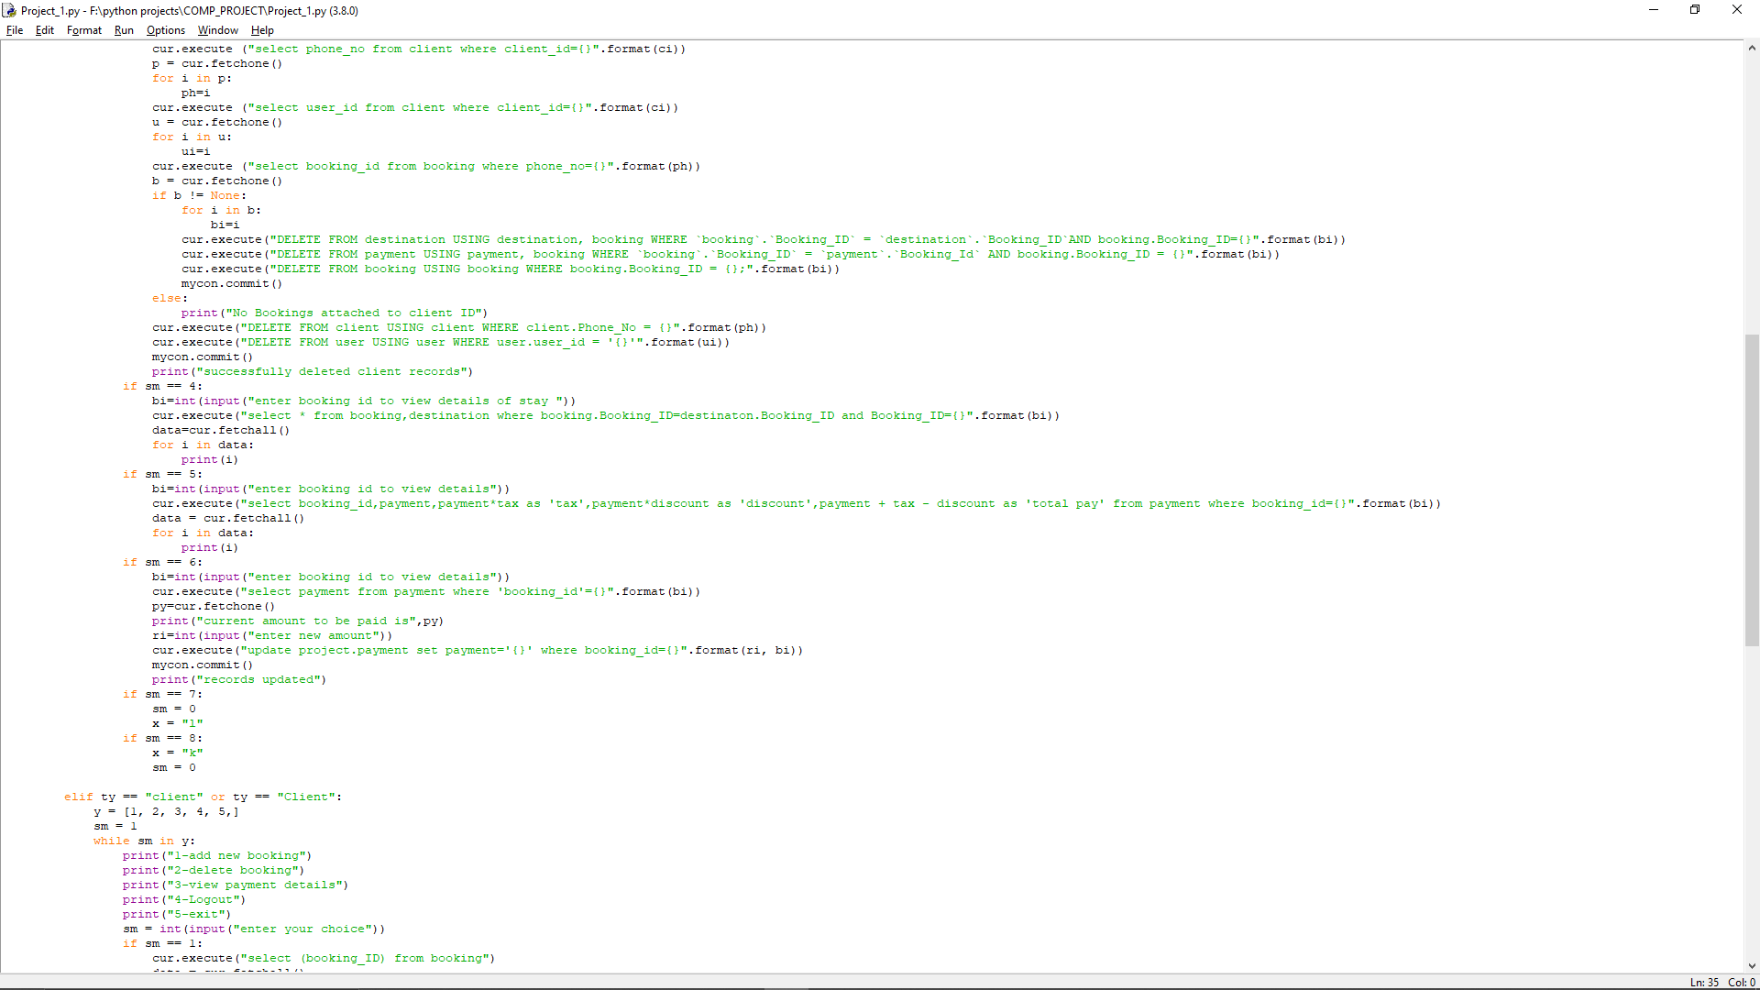

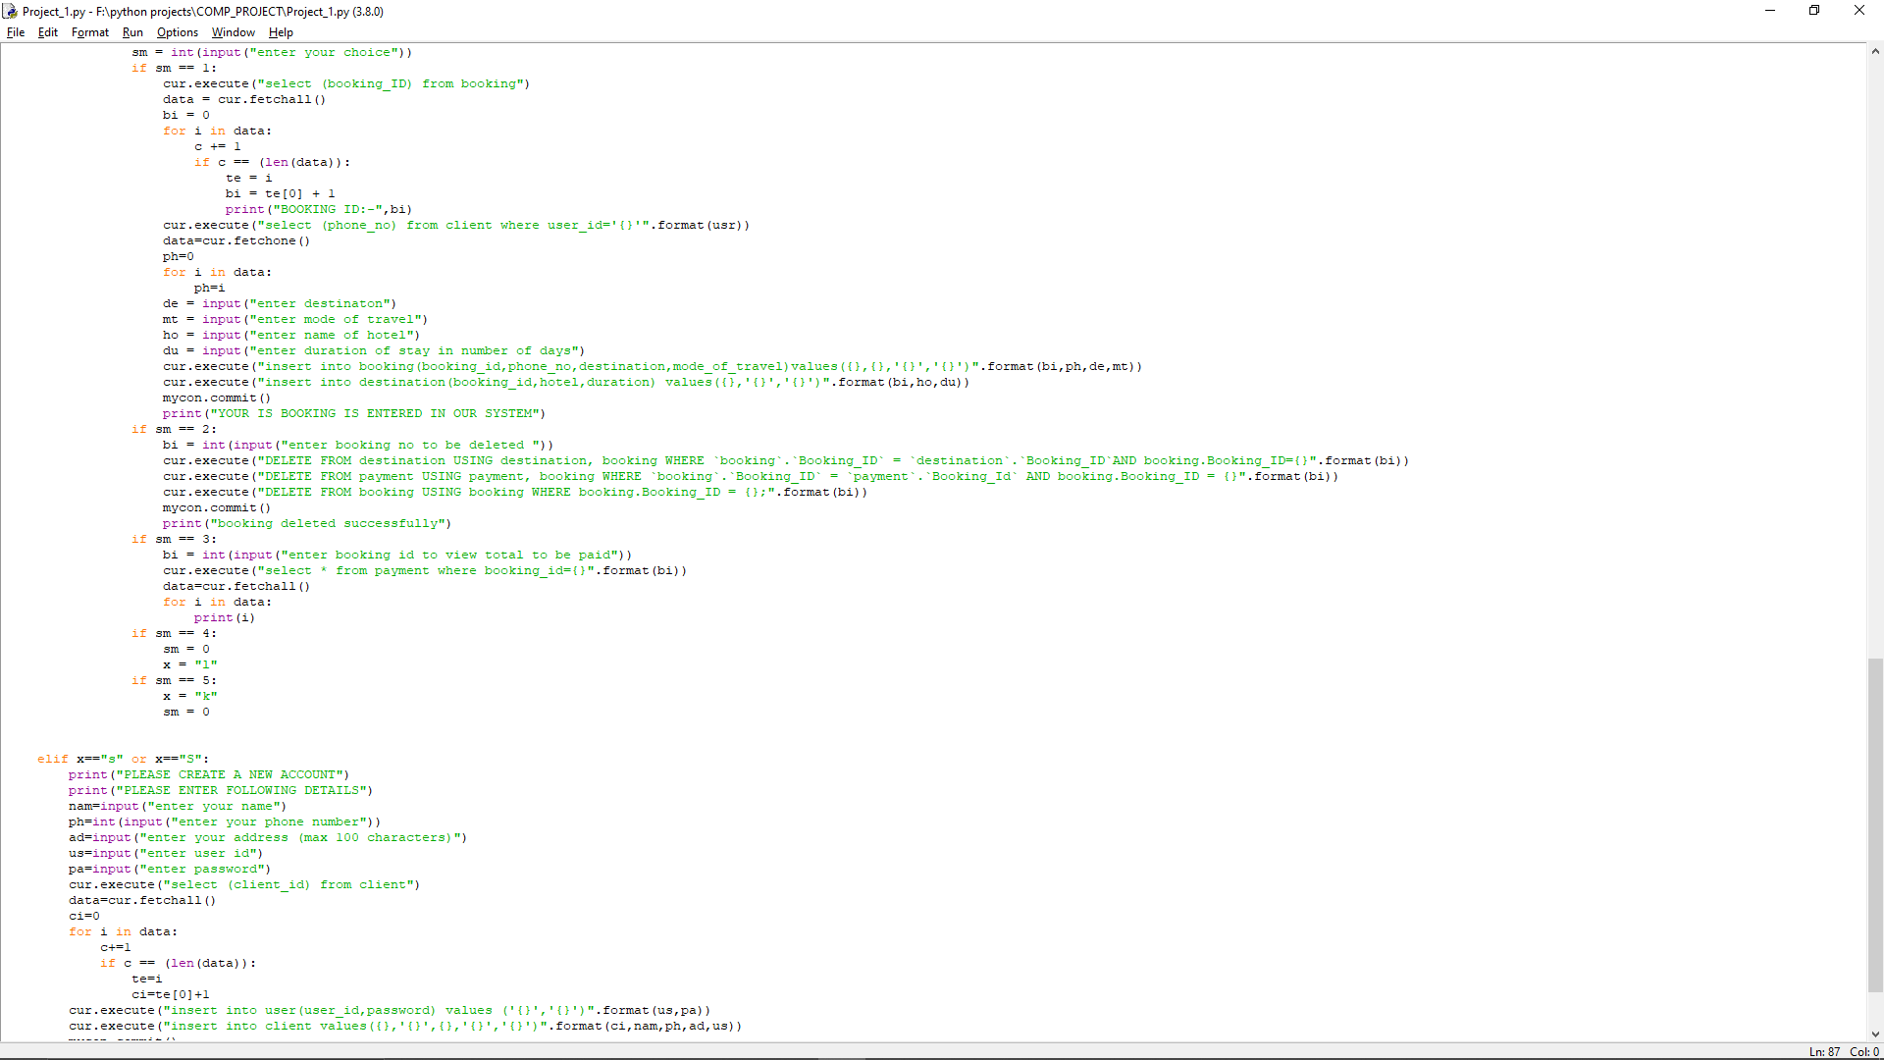

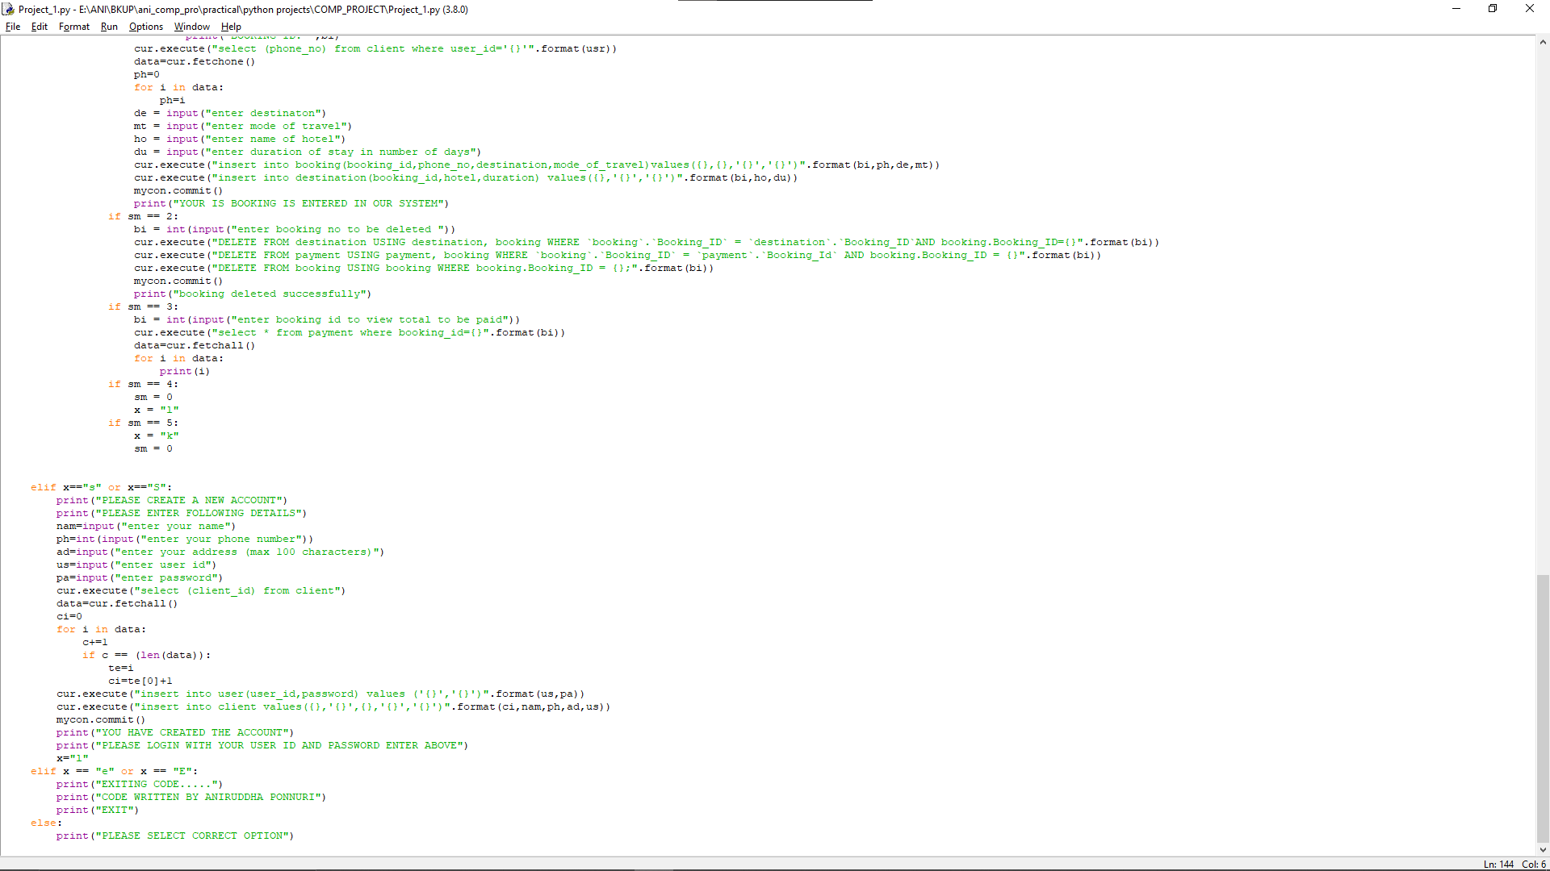

Project output:

SIGN UP: --

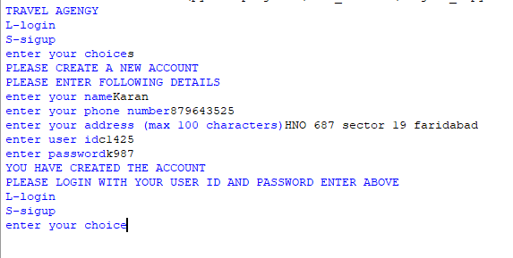

LOGIN (client view)

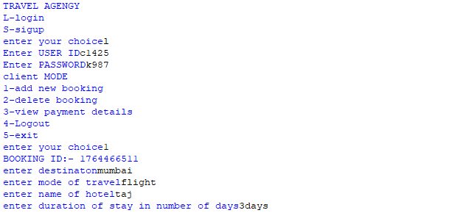

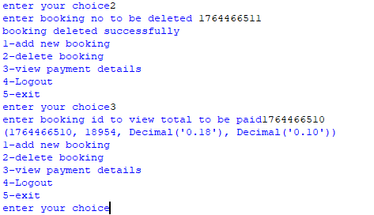

Login (admin view)

